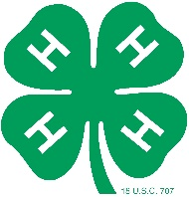
Ocean County 4-H 2021-2022
Club Awards Nomination Form

**Please complete one form for each nomination**

Due by November 14th, 2022

These awards recognize the cooperative efforts and dedication of Ocean County 4-H clubs.
You can nominate your club, or another club that inspires you. (Honors Handbook, page 22)

Your Name: __________________________________________________________________________

Your primary club: _____________________________________________________________________

I am an Ocean County 4-H (check one box): Member Volunteer

Thank you very much for taking the time to nominate a 4-H club!

Club Nomination Information

Club Name: __________________________________________________________________________

Award Deserved – Please select only one per nomination form:

- 4-H Community Development Award ◻ 4-H Public Relations Award
◻ 4-H Loyal Heart Award

Why does this club deserve the award?

Submit by November 14th to: Ocean County 4-H Youth Development Program
1623 Whitesville Road
Toms River, NJ 08755
732-349-1227

