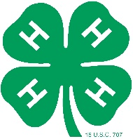
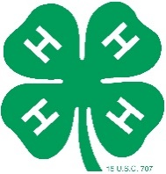
Ocean County 4-H 2021-2022
Volunteer Specialty Awards Nomination Form

**Please complete one form for each nomination**
Due by November 14th, 2022

Volunteer specialty awards are meant to recognize particular volunteers with great dedication to 4-H.
Any 4-H volunteer or member can nominate a volunteer for these awards.
(Honors Handbook, page 24- 25)

Your Name: __________________________________________________________________________

Your primary club: _____________________________________________________________________

I am an Ocean County 4-H (check one box): Member Volunteer

Thank you very much for taking the time to nominate a 4-H volunteer!

Volunteer Nominee Information

Last Name: _______________________________ First Name: ________________________________

Award Deserved – Please select only one per nomination form:

- Ocean County 4-H Leader of the Year ◻ Community Leadership Award

- The Helping Hand Award ◻ 4-H Alumni Award

Club(s) the nominee works with: ______________________________________________________________
Why this nominee deserves this award?
____________________________________________________________________________________________________________________________________________________________________________________________________________________________________________________________________________________________________________________________________________________________________________________________________________________________________________________________________________________________________________________________________________________________________________________________________________________________________________________________________________________________________________________________________________________________________________________

Submit by November 14th to: Ocean County 4-H Youth Development Program
1623 Whitesville Road
Toms River, NJ 08755
732-349-1227

